Docker Task 01

Introduction to Docker
Docker is a containerization platform used to run applications inside lightweight containers. Before Docker, applications were deployed using virtualization. Docker introduced containerization, which is faster and more lightweight.

Virtualization – Key Points
- Runs multiple operating systems on one physical machine
- Each VM has its own OS and kernel
- Uses a hypervisor (VirtualBox, UTM, VMware)
- Heavy and slow to start
- Uses more RAM and CPU
- Used when a full OS environment is required

Docker – Key Points
- No full OS required
- Shares host OS kernel
- Lightweight and fast
- Packages app and dependencies together
- Starts in seconds
- Uses images to create containers
- Widely used in DevOps and cloud

1) Setup a virtual machine using Ubuntu image.
Step 1: Download Ubuntu ISO
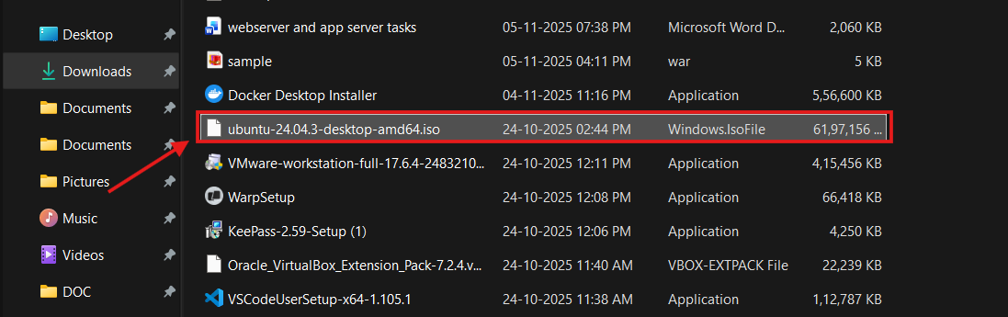
Step 2: Create an Ubuntu Virtual Machine
Install
- Open UTM → Click + → Create → Virtualize → Linux
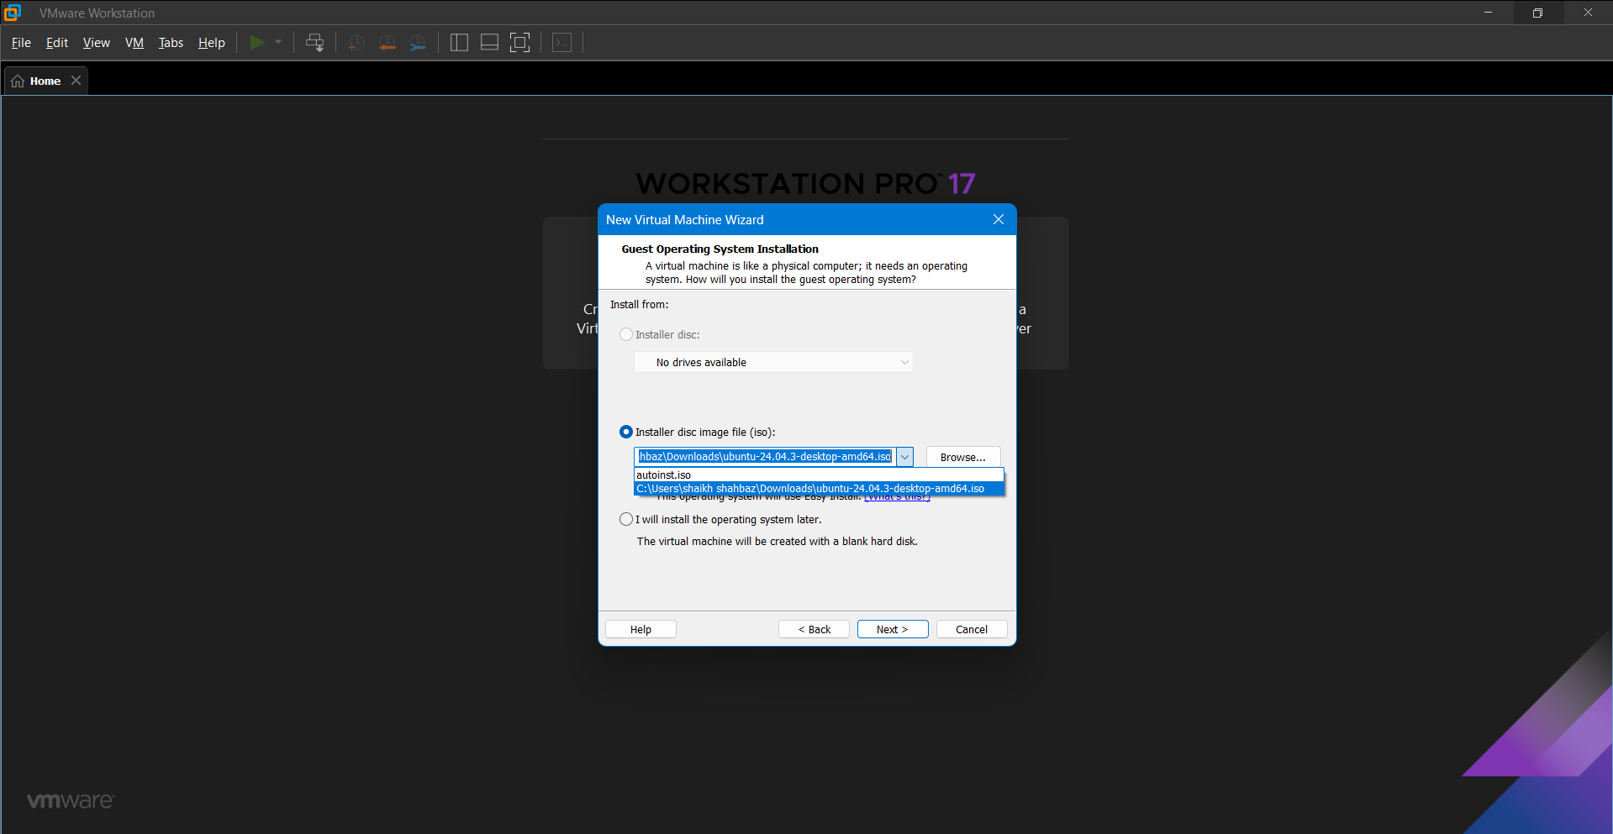
Step 3: Create Ubuntu VM
- Architecture: ARM64
- Memory: 4GB
- Storage: 12–20GB
- Network: Shared (NAT)
Step 4: Install Ubuntu OS
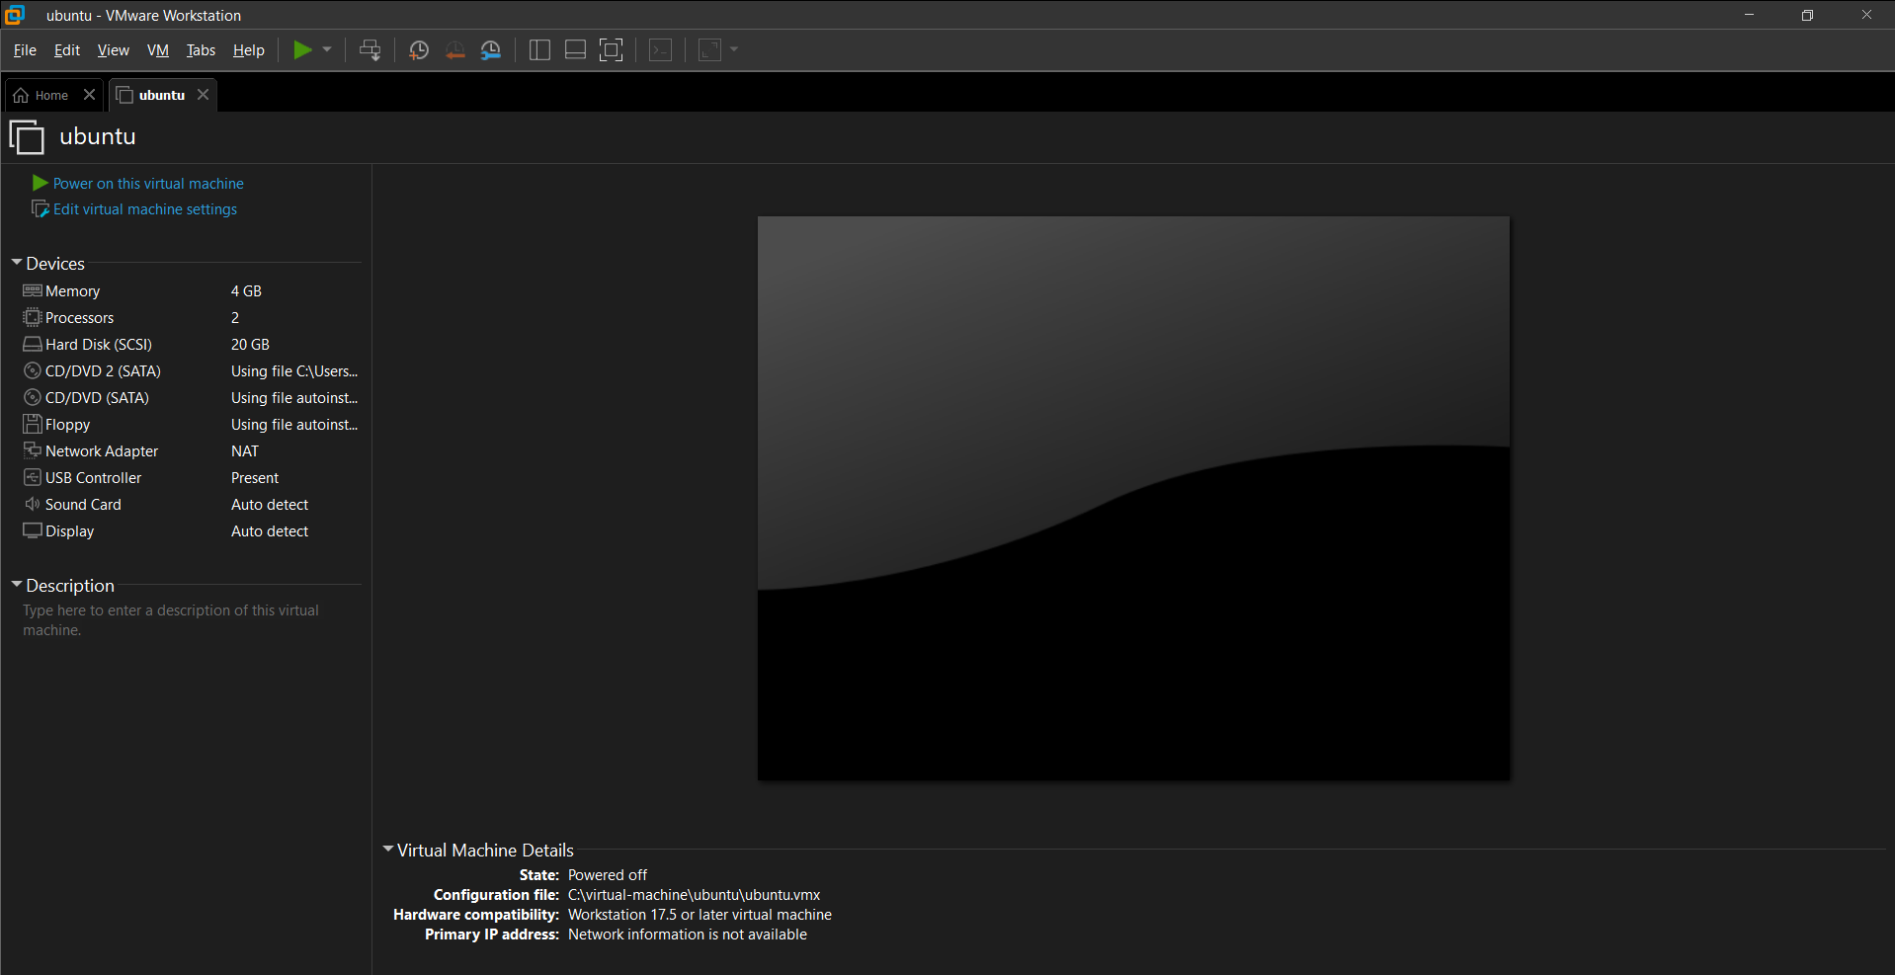
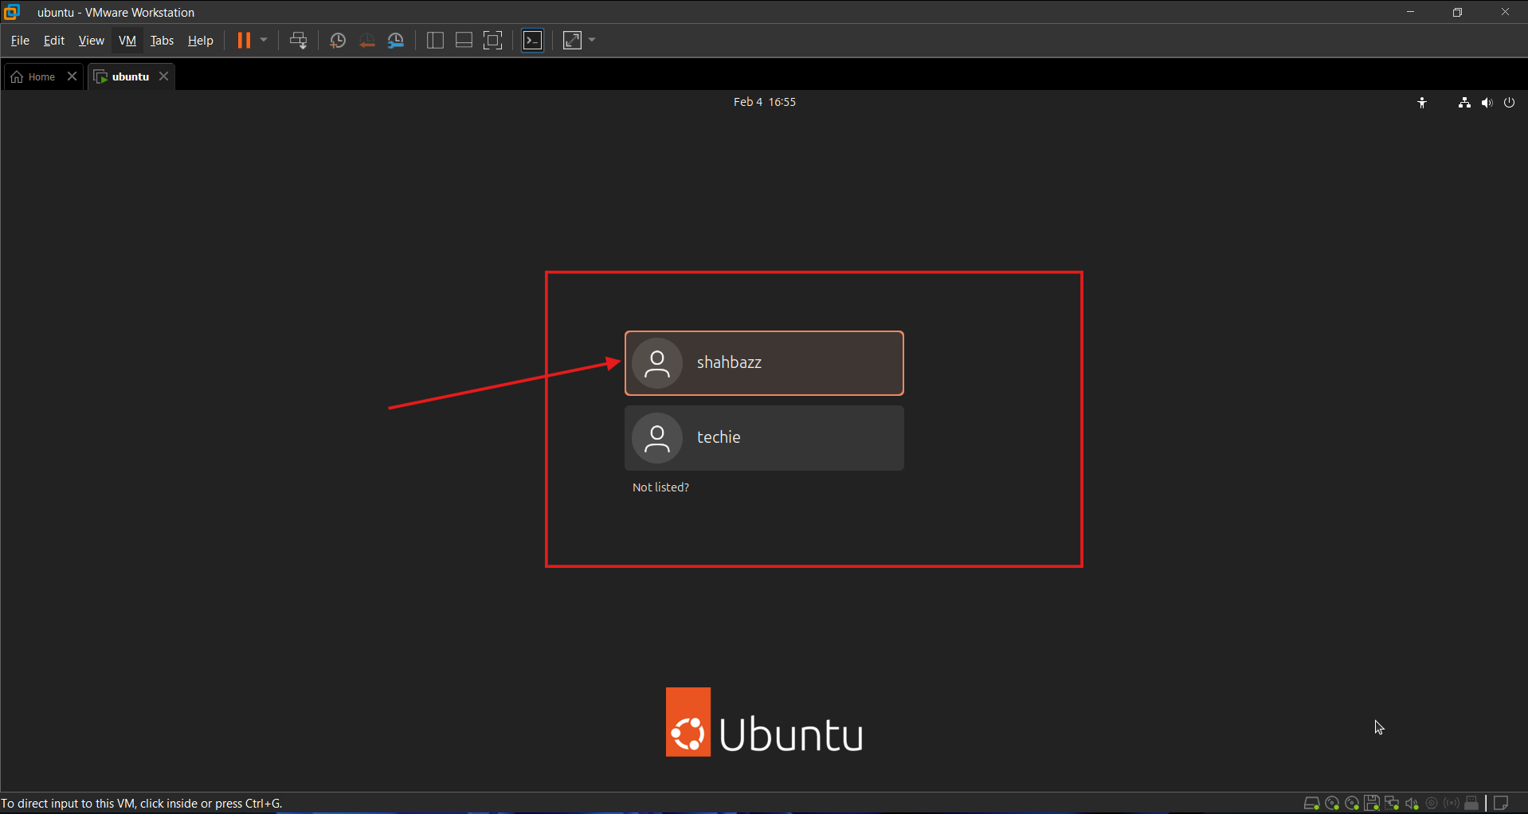
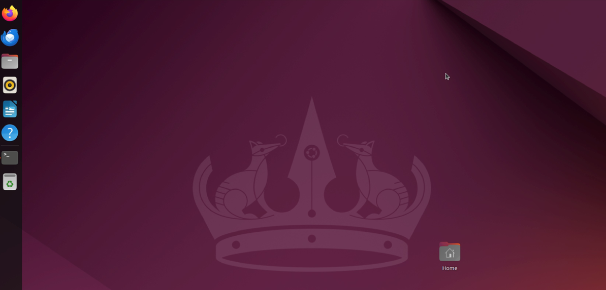
Step 5: Switch to root user
sudo su -
Step 6: Install and verify Nginx
apt update
apt install nginx -y
systemctl start nginx
systemctl status nginx
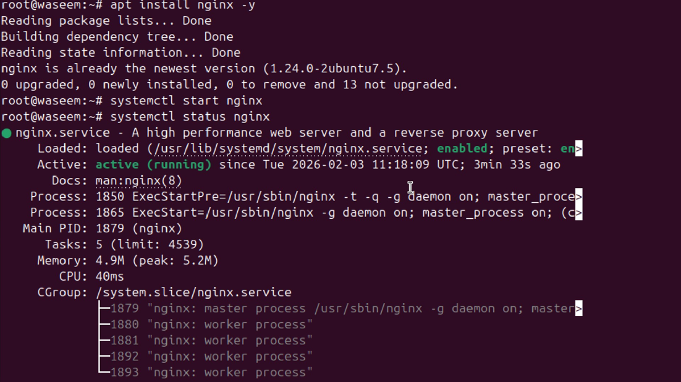

Validate: On Ubuntu Browser (Mozilla)
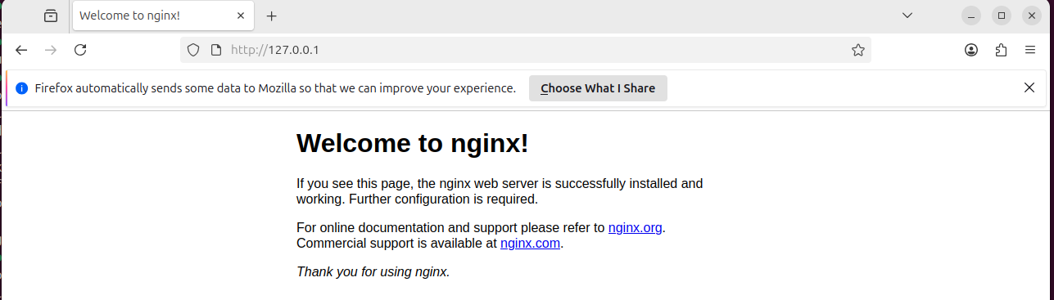

2) Install docker on ec2.
Prerequisites:
EC2 instance (t3.large)
Large storage volume
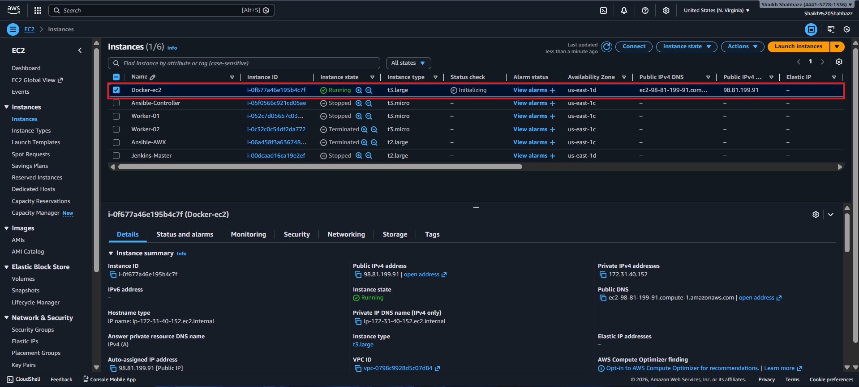
Commands:
yum update -y
yum install docker -y
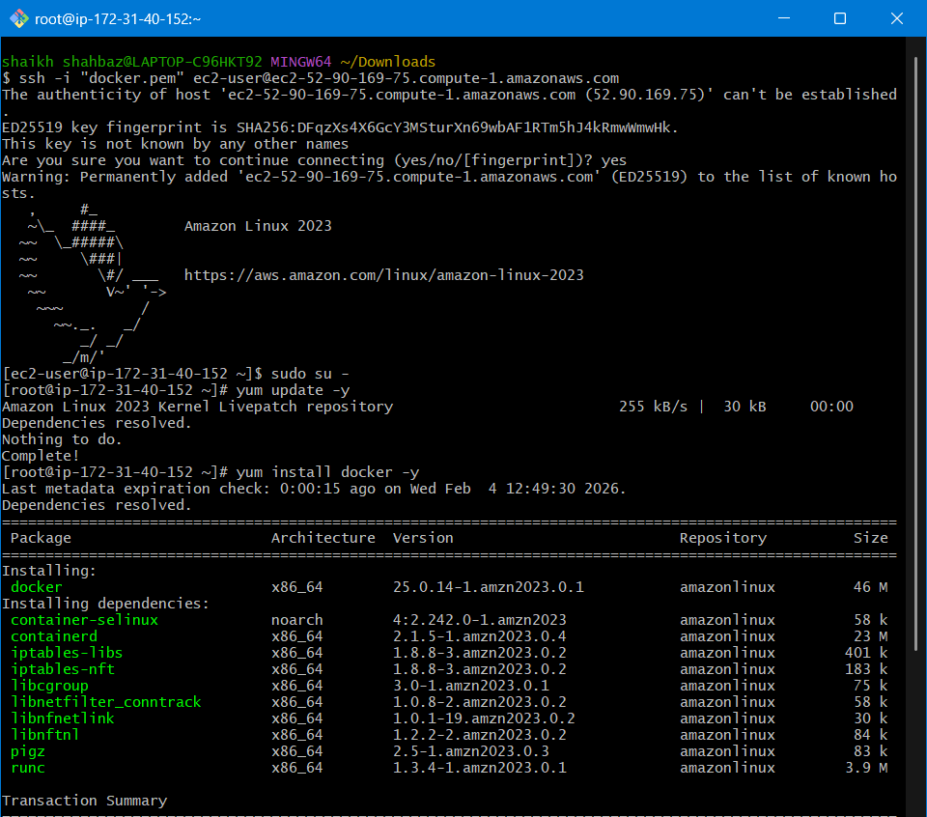
systemctl start docker
systemctl status docker
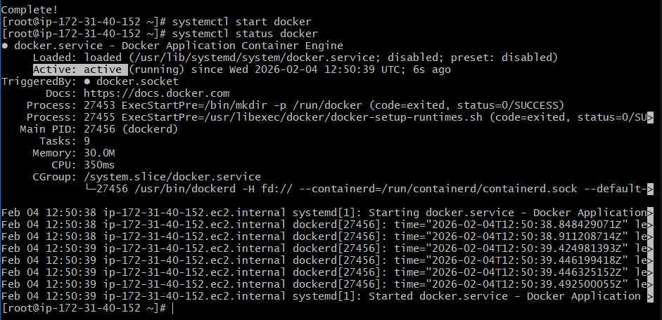

3) Pull 5 docker images. (nginx, apache tomcat, ubuntu, jenkins, sonarqube)

docker pull nginx
docker images
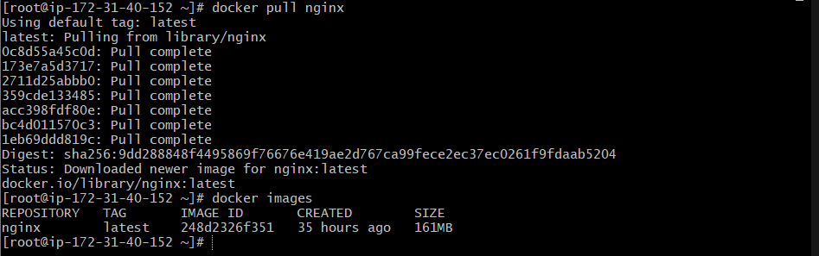

docker pull tomcat
docker images
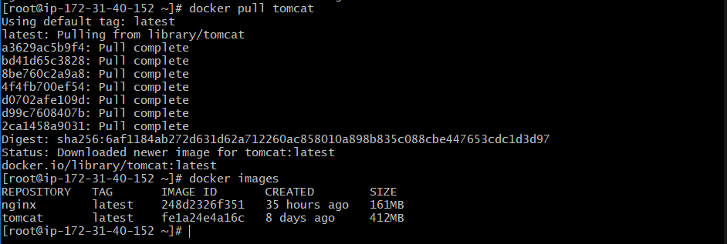

docker pull ubuntu
docker images
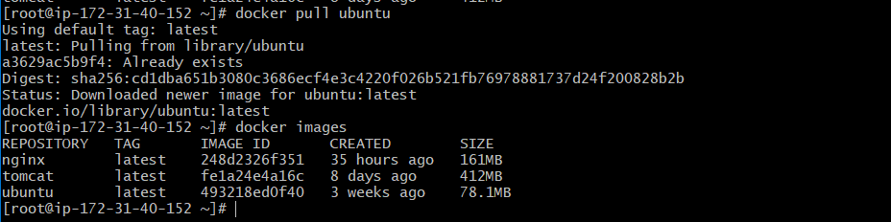
docker pull jenkins/Jenkins
Means:
docker.io/jenkins/jenkins
- jenkins (namespace) → Jenkins organization
- jenkins (repo) → Jenkins image
This is the official image published by the Jenkins team
That’s why it works
docker images
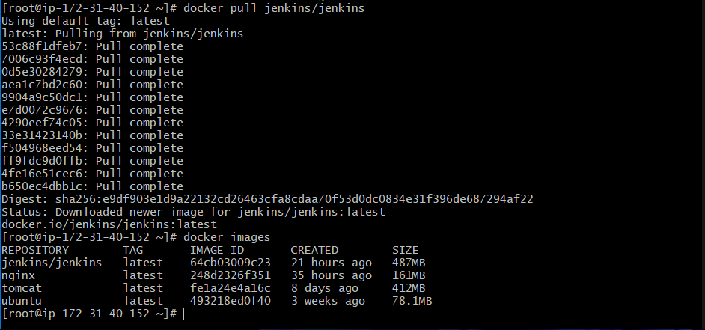
docker pull sonarqube
docker images
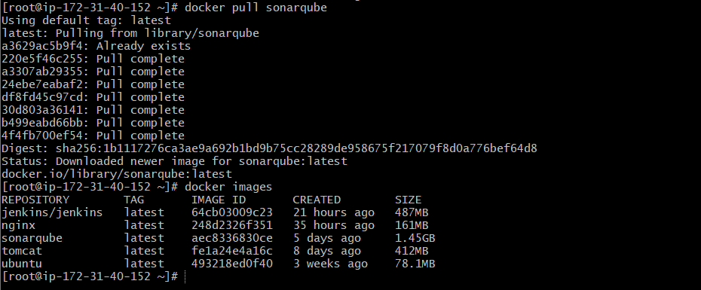
Check images:
docker images pulled all 5 images
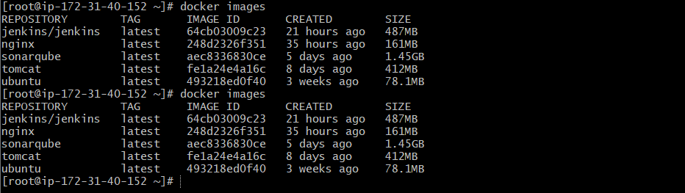

4) Run nginx container and expose on port 81.

The command to access our container through browser, we use -p parameter (port mapping)
81 new port to access on browser or to expose it to the outer world
80 it the default port no. that is only accessed within our server not on the browser

For that we have one docker command
docker run -d -p 81:80 nginx
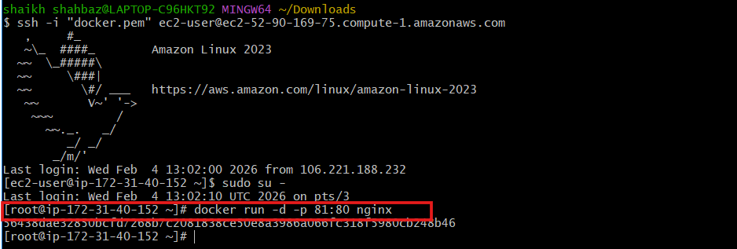
Verify:
docker ps
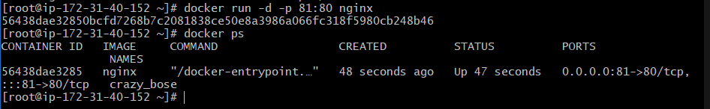
Access: http://<public-ip>:81
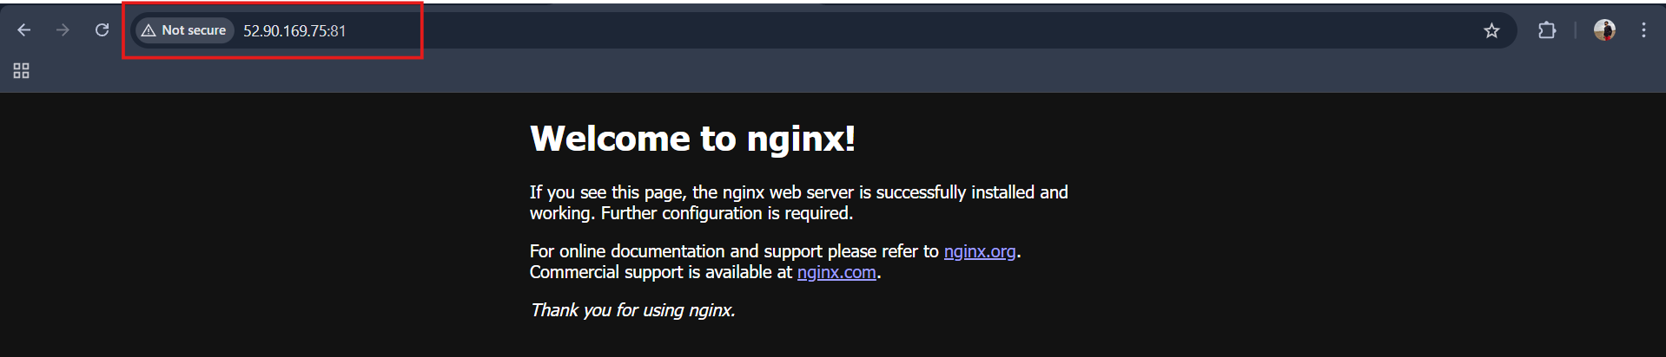

5) Delete the apache tomcat image from local.
To delete remove the images from the docker container we have the below command
Remove the Apache Tomcat image
docker rmi tomcat
docker images
Verify image removal
docker images
The tomcat image should no longer appear in the list.

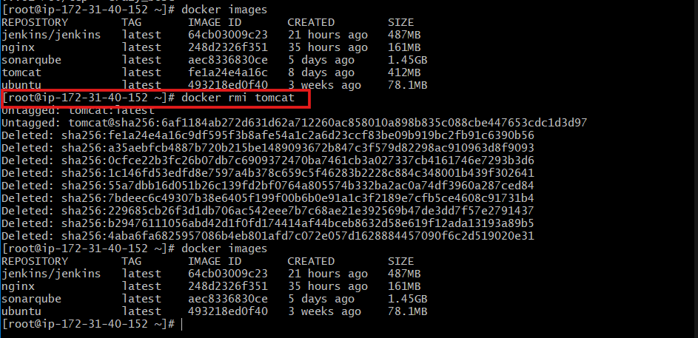

6) Inspect the jenkins image, sonarqube image.
To get all the details related to container we use inspect command
What docker inspect shows
The docker inspect command returns output in JSON format and provides:
Image-level details
- Image ID & SHA
- Repo tags
- Created time
- Size
- Architecture & OS
- Entrypoint & CMD
- Exposed ports
- Environment variables
- Working directory
- Labels & metadata
Inspect a running container (extra)
If Jenkins or SonarQube is running as a container, you can inspect the container itself:
docker ps
docker inspect <container_name>
This additionally shows:
- Container IP address
- Mounted volumes
- Network settings
- Resource limits
- Container state (running, stopped)

docker inspect jenkins/jenkins
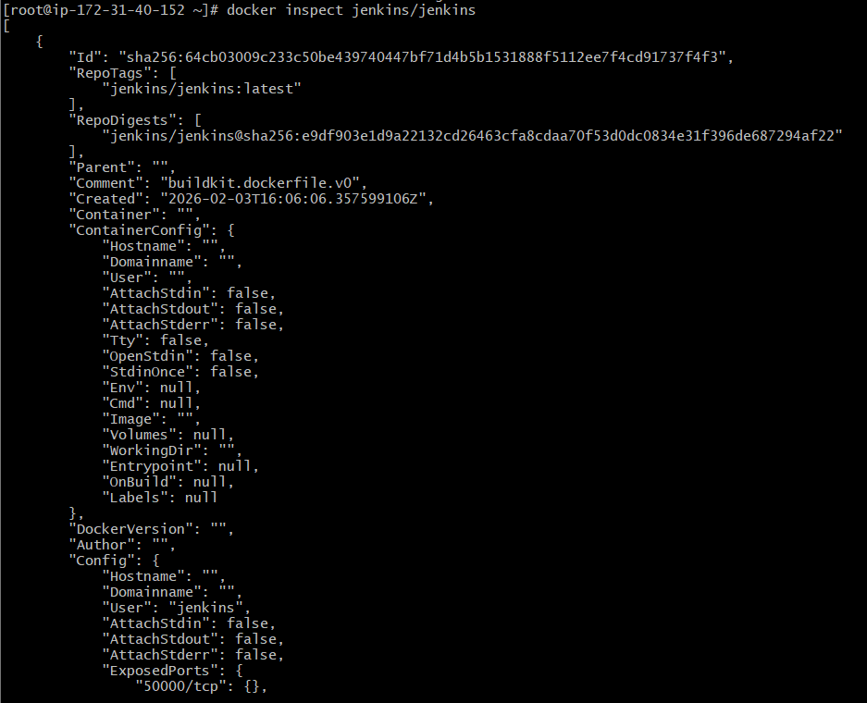
docker inspect sonarqube
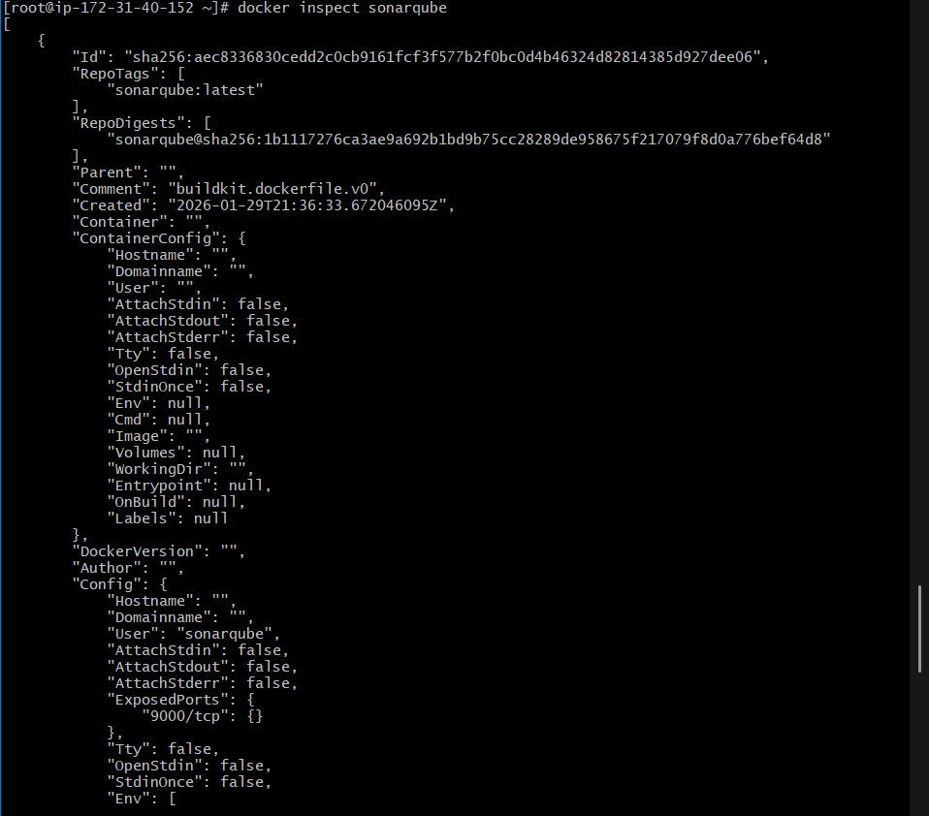

7) Run jenkins contianer and run one sample job.
Step 1: Run Jenkins container
Pull and run the official Jenkins image:
docker run -d -p 8080:8080 -p 50000:50000 jenkins/jenkins
docker ps
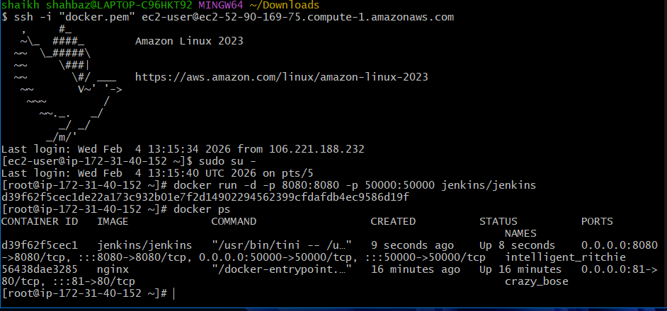
Step 2: Access Jenkins UI
Open your browser:
Access: http://<public-ip>:8080
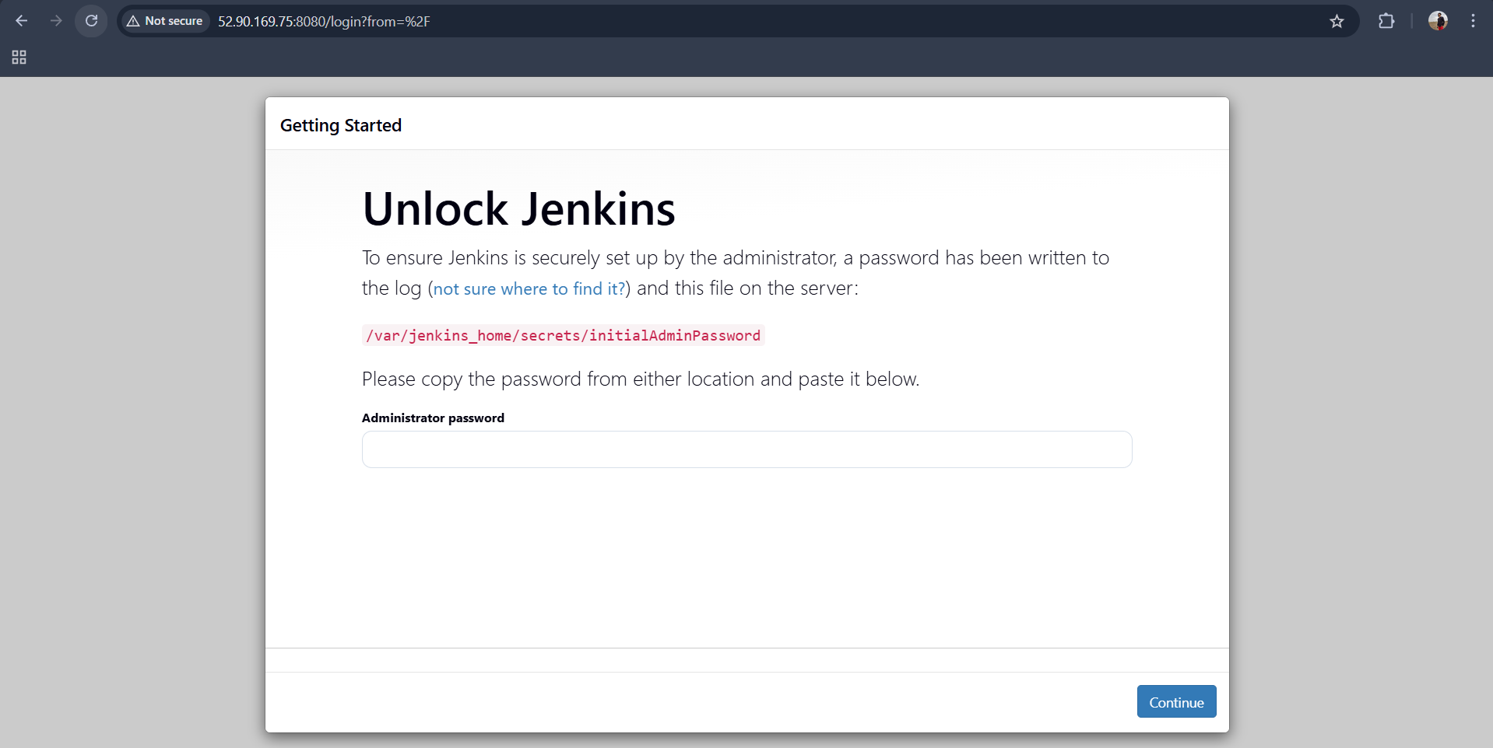
Step 3: Get admin password:
docker exec <container_name> cat /var/jenkins_home/secrets/initialAdminPassword
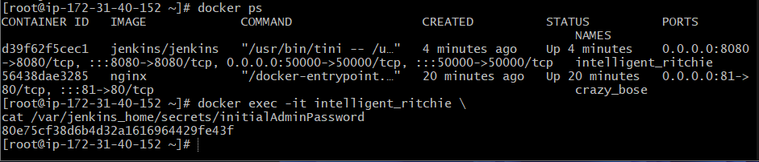
Step 4: Complete Jenkins setup
- Click Install suggested plugins
- Create Admin User
- Finish setup and land on Jenkins dashboard

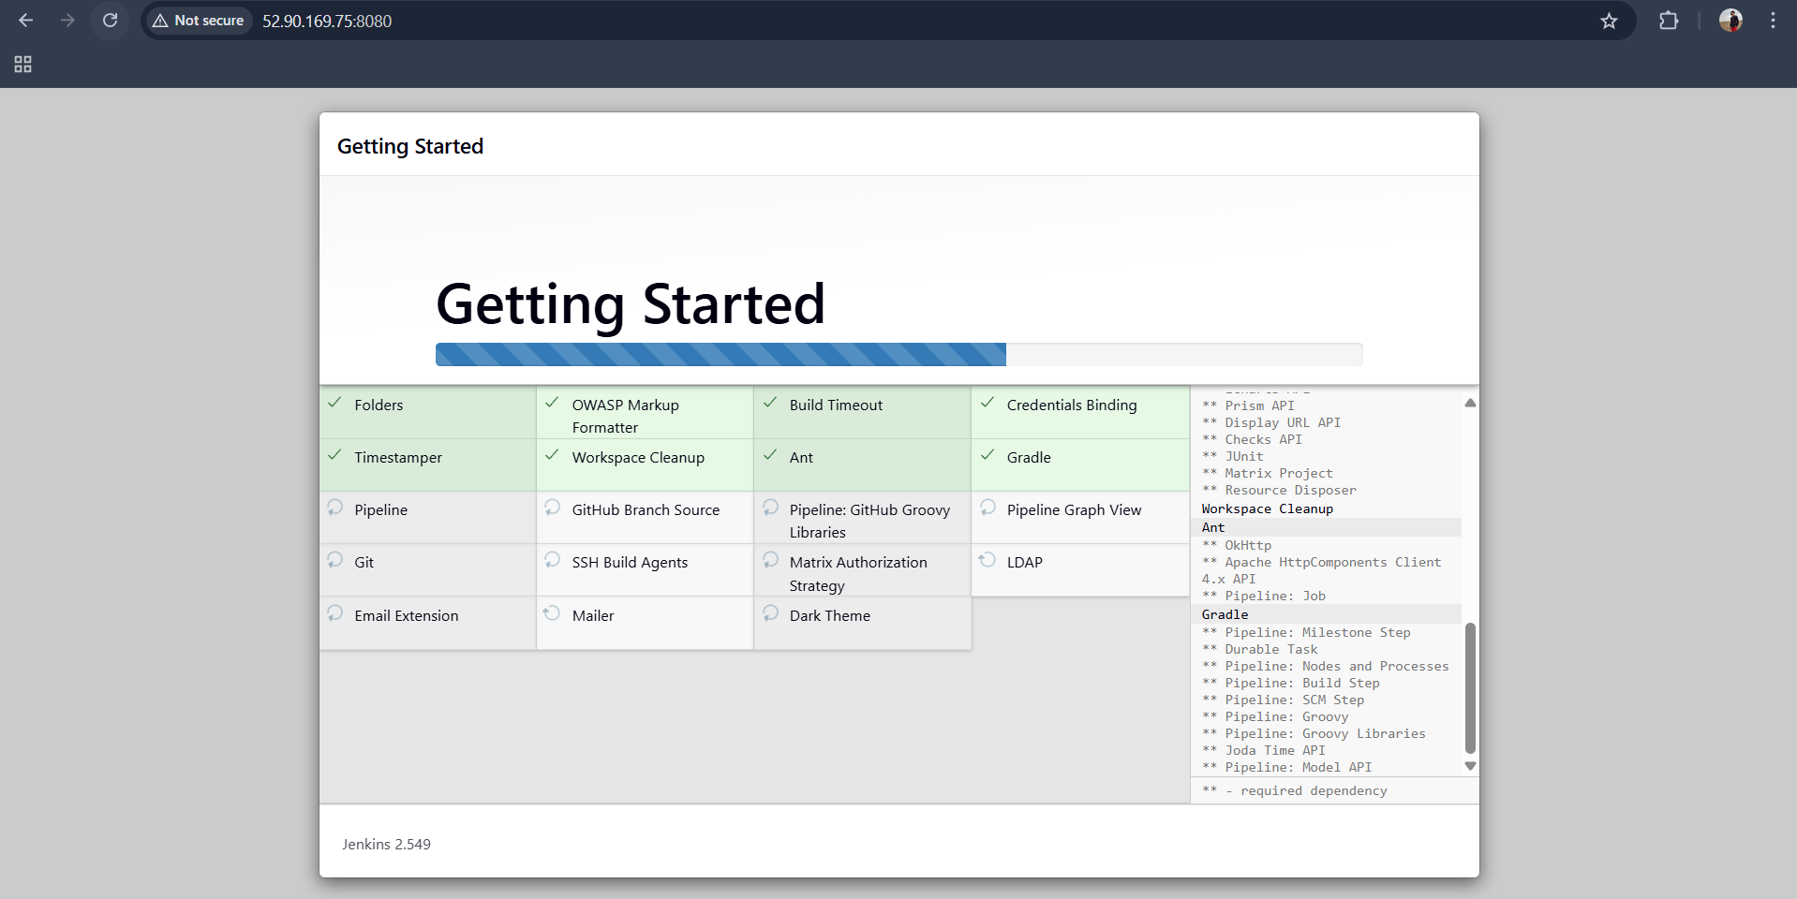
Login → Create Pipeline Job → Run Job
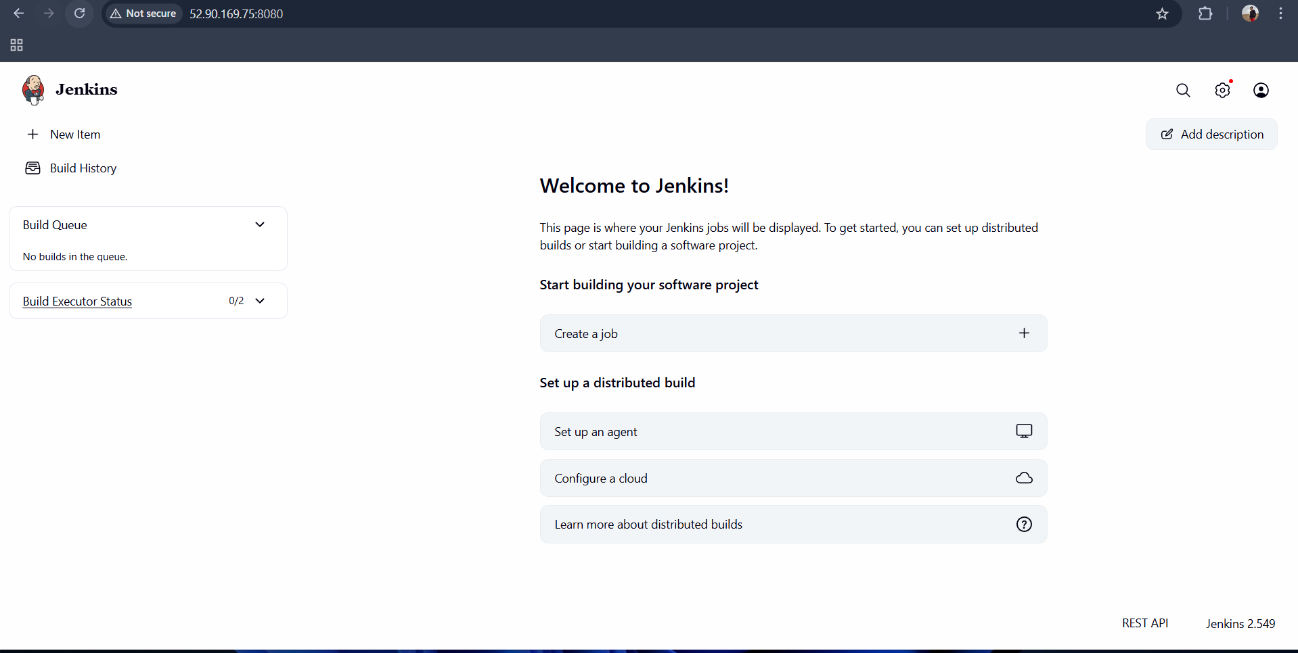
Step 5: Create a sample Pipeline job
- Click New Item
- Enter job name:
sample-job
- Select Pipeline
- Click OK

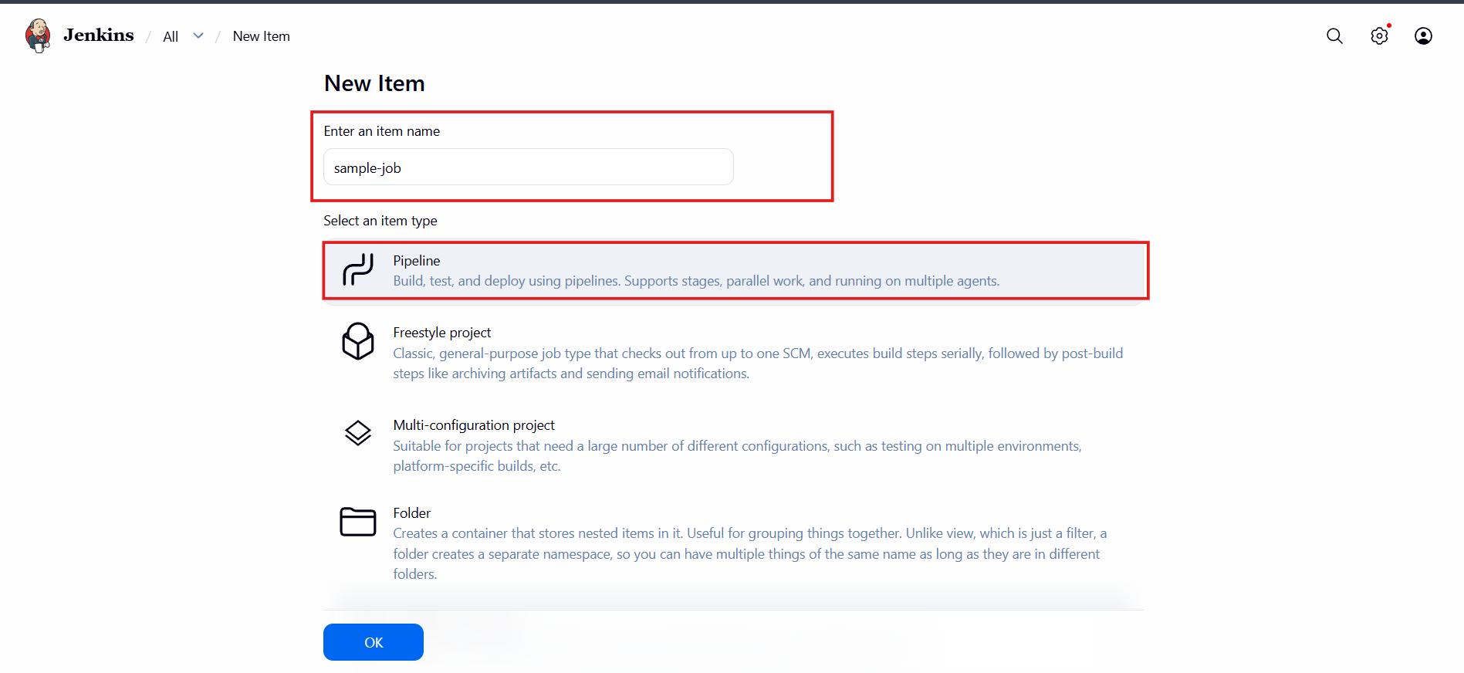

Sample pipeline:
pipeline {
agent any

stages {
stage('Hello') {
steps {
echo 'Hello World'
}
}
}
}
Click Save
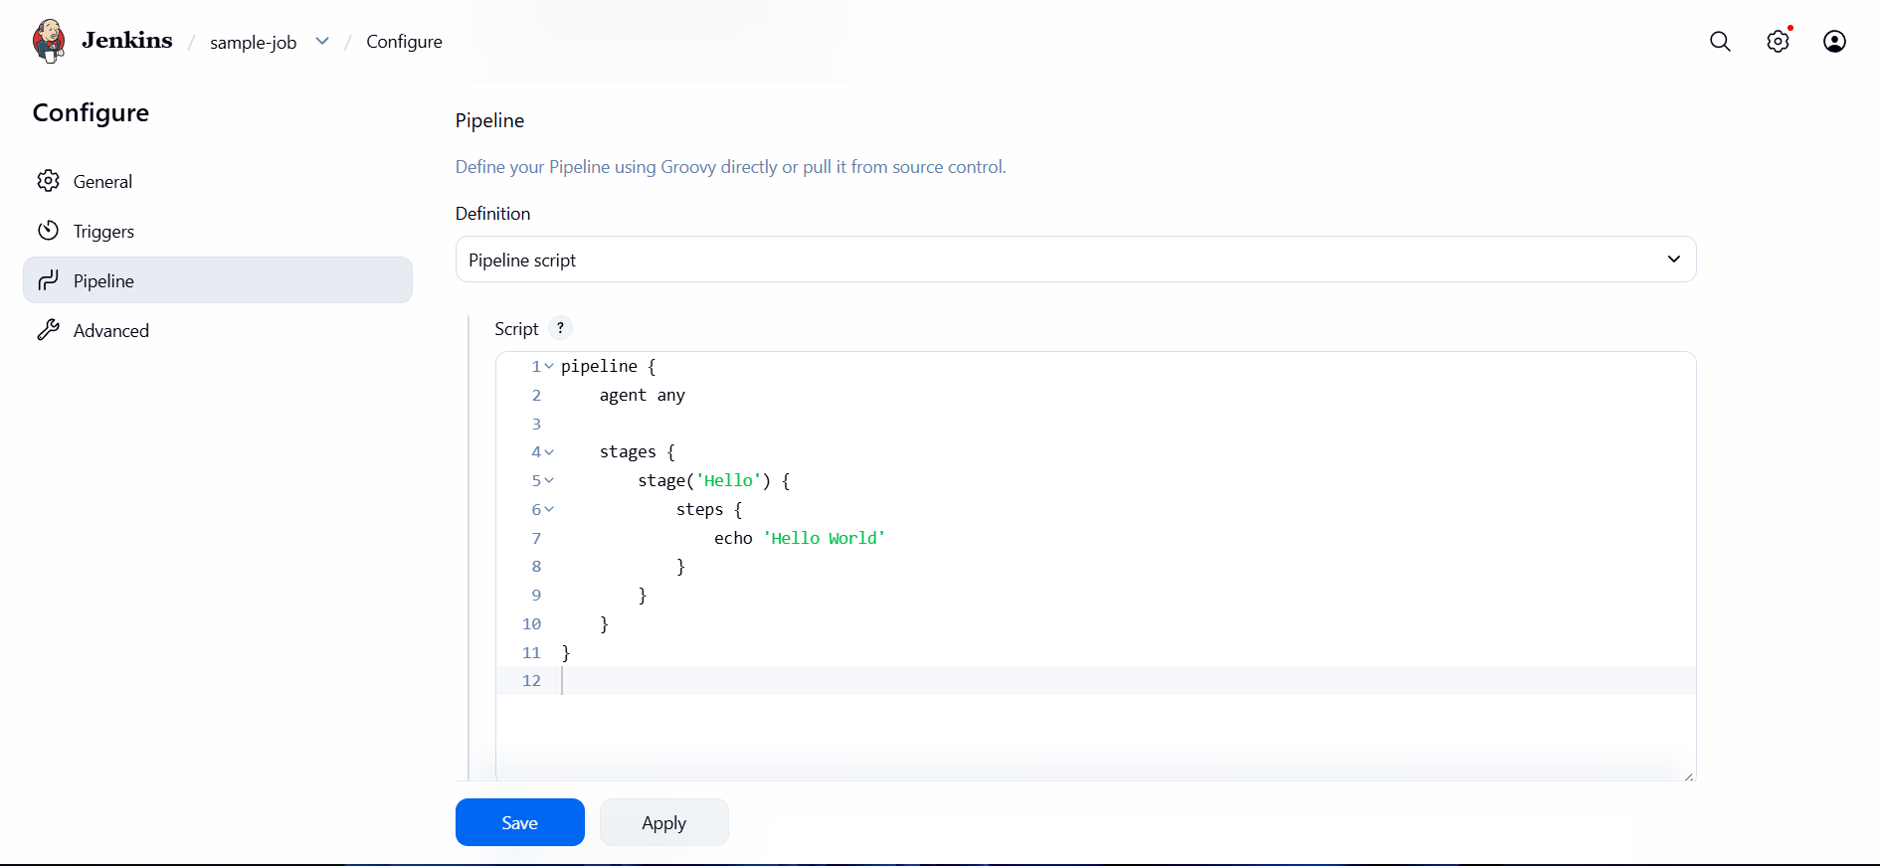

Click Save and Build

Step 7: Run the job
- Click Build Now
- Open Build #1
- Check Console Output

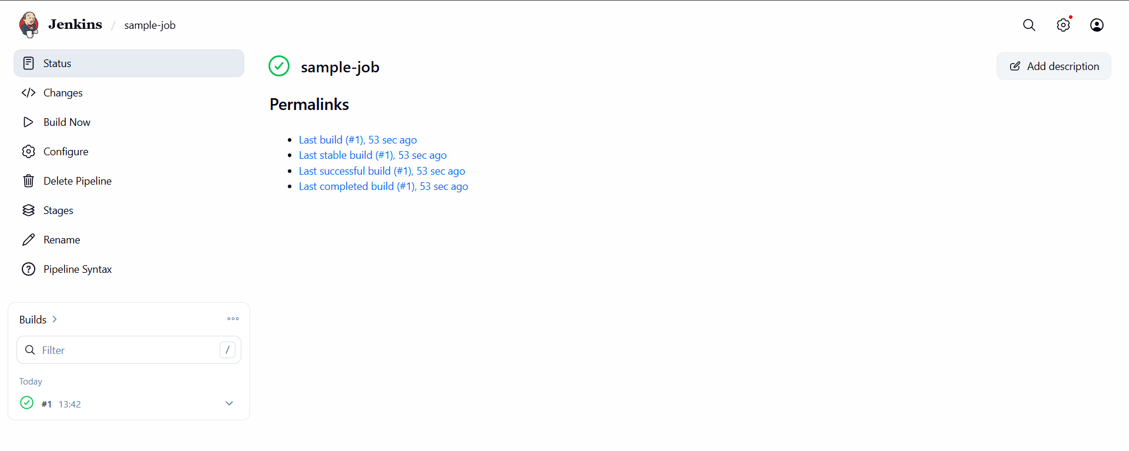
Pipeline overview:
